* **Steps**: For configure a budget.

1. Log in to AWS console, go to your username and there click on ‘Billing and Cost Management’.

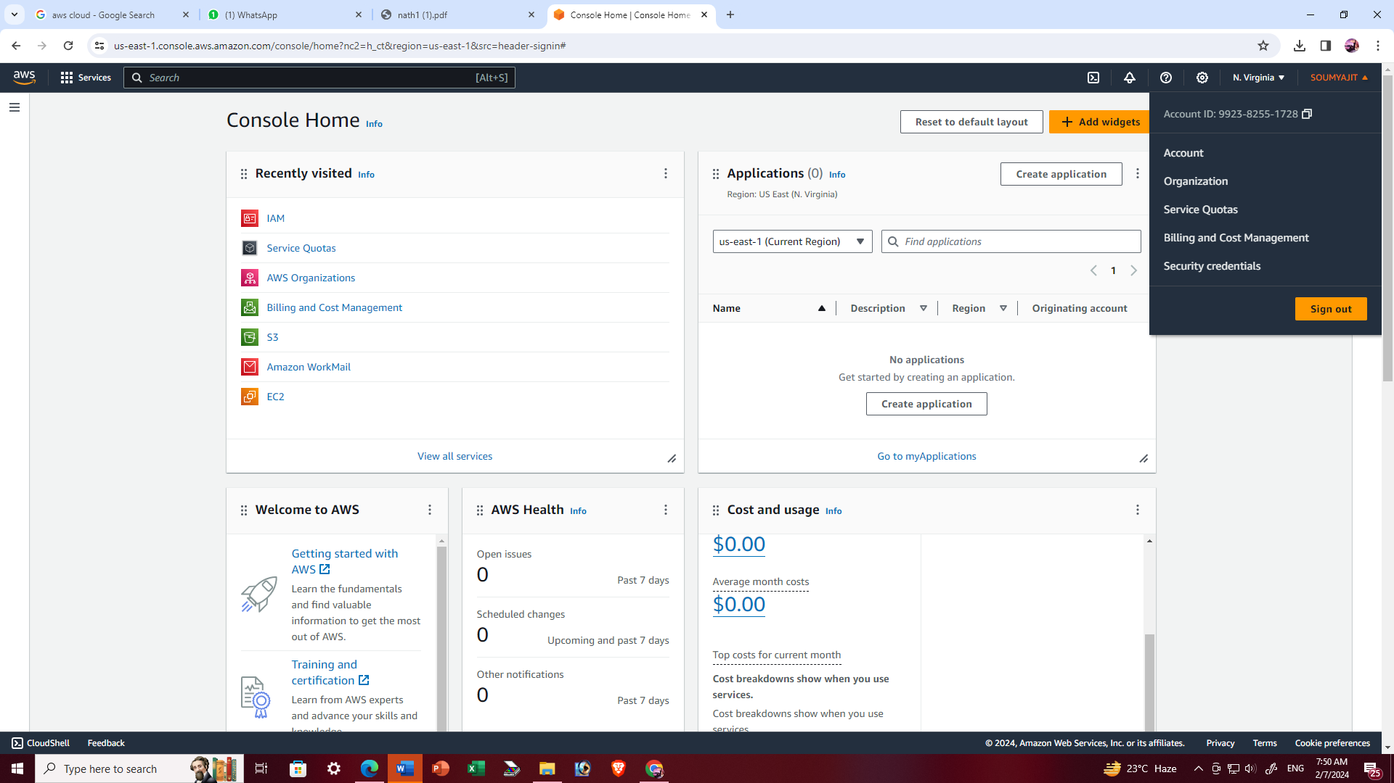

1. Under ‘Budgets and Planning’, click on ‘Budgets’.

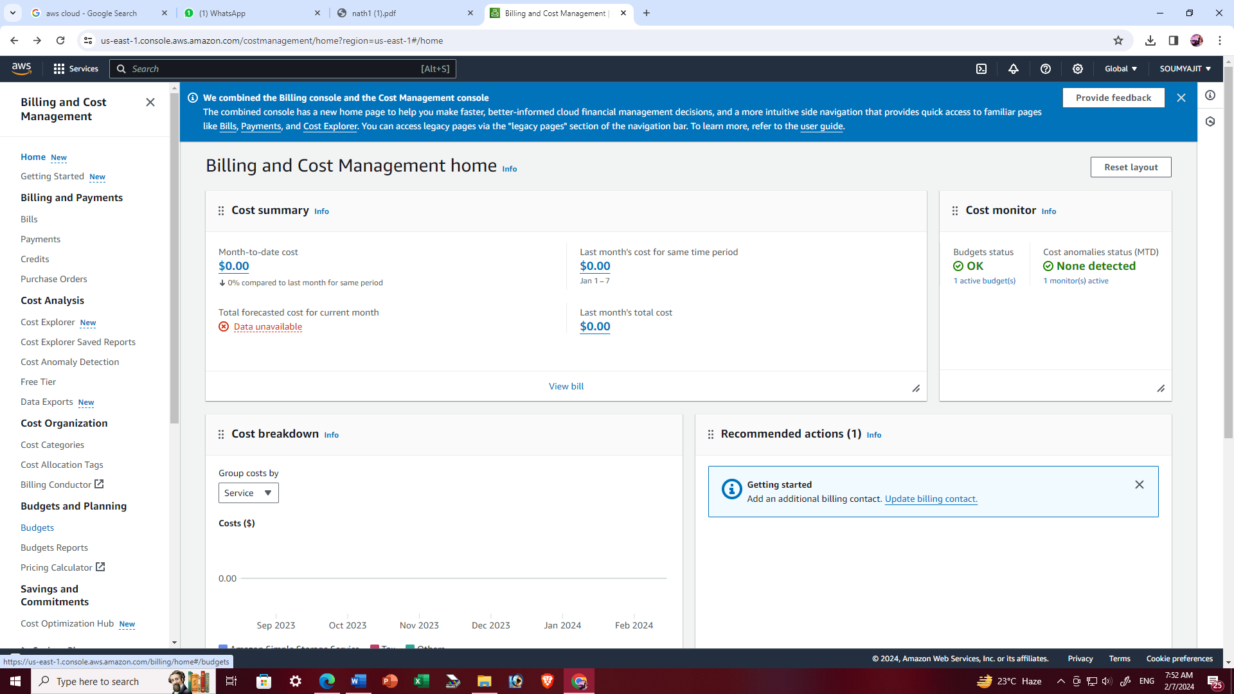

1. And then click ‘create budget’.

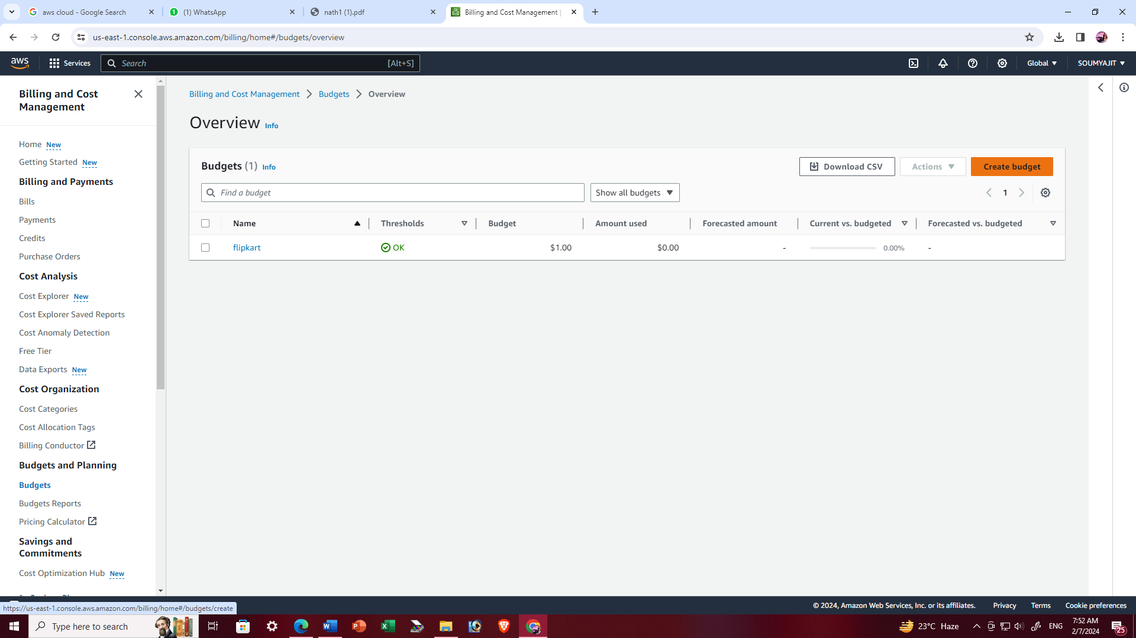

1. Configure budget setup and chose the budge type -> click on Customize(advanced) button then click on ‘Next’.

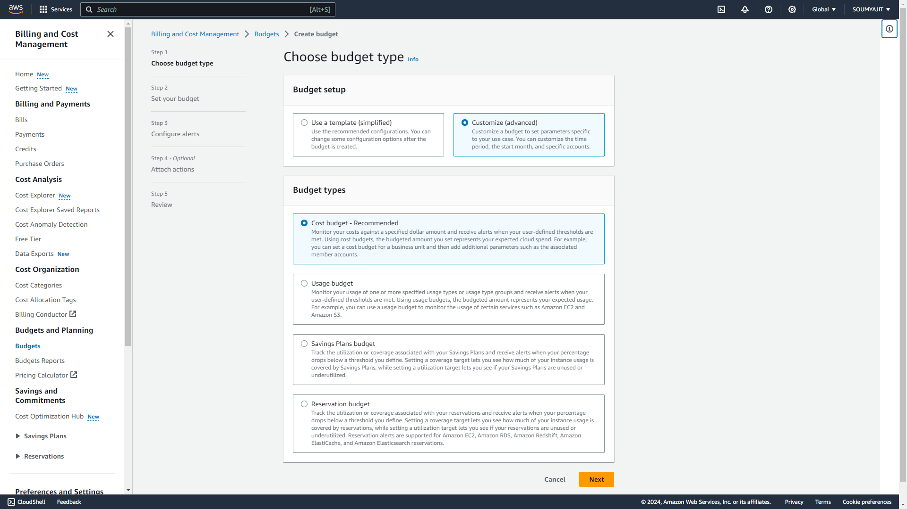

1. Add budget details and click on the ‘Next’.

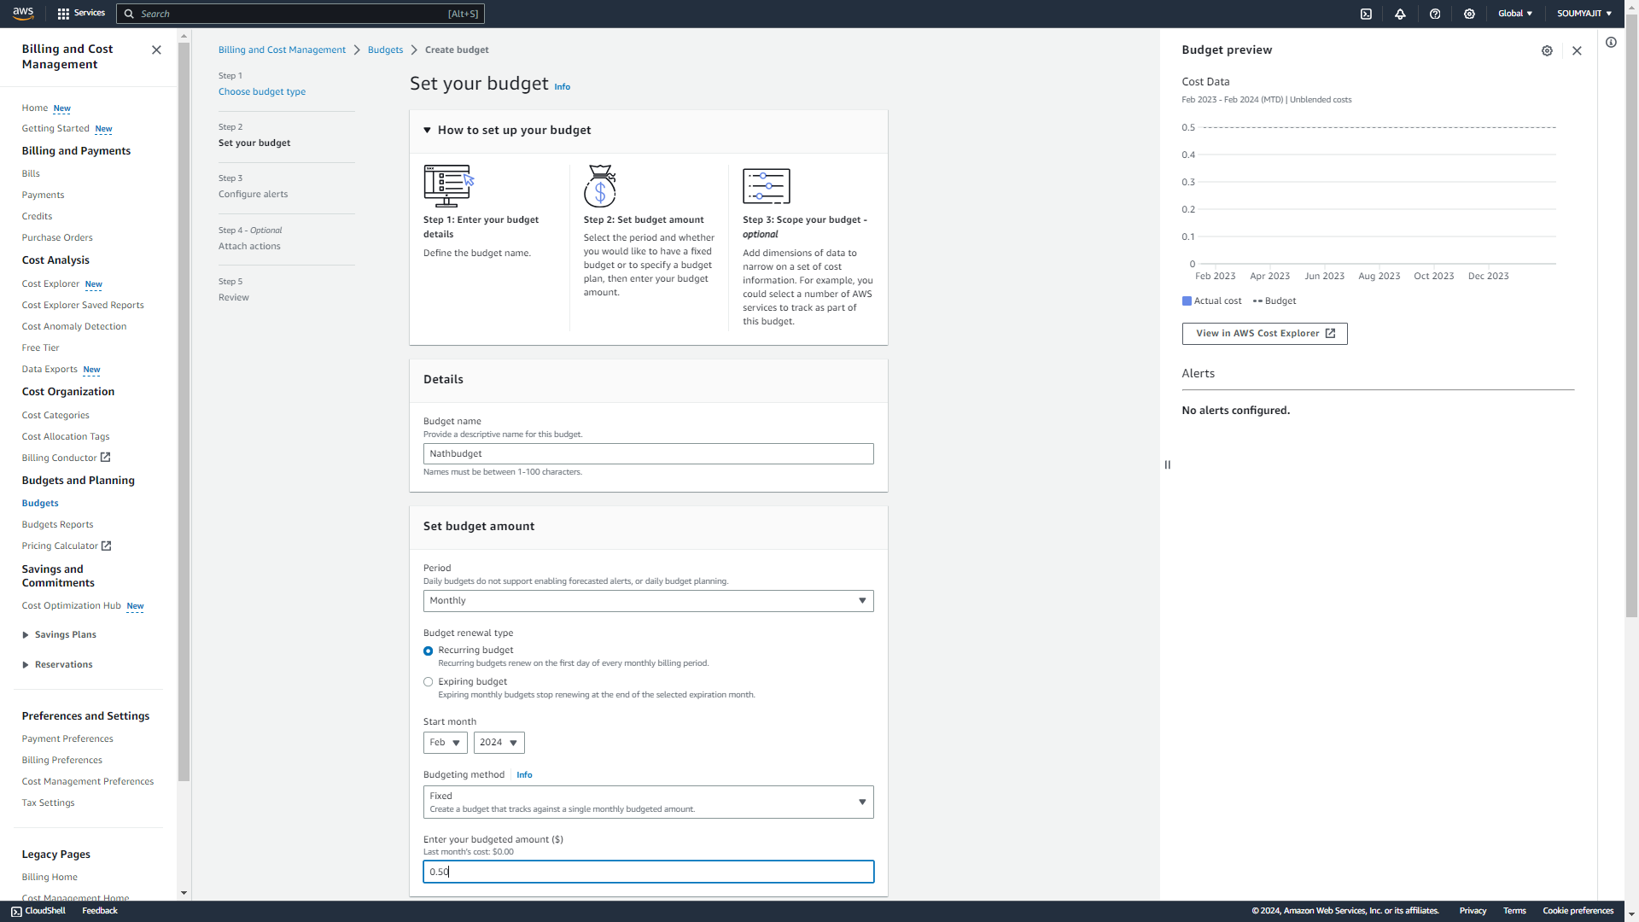

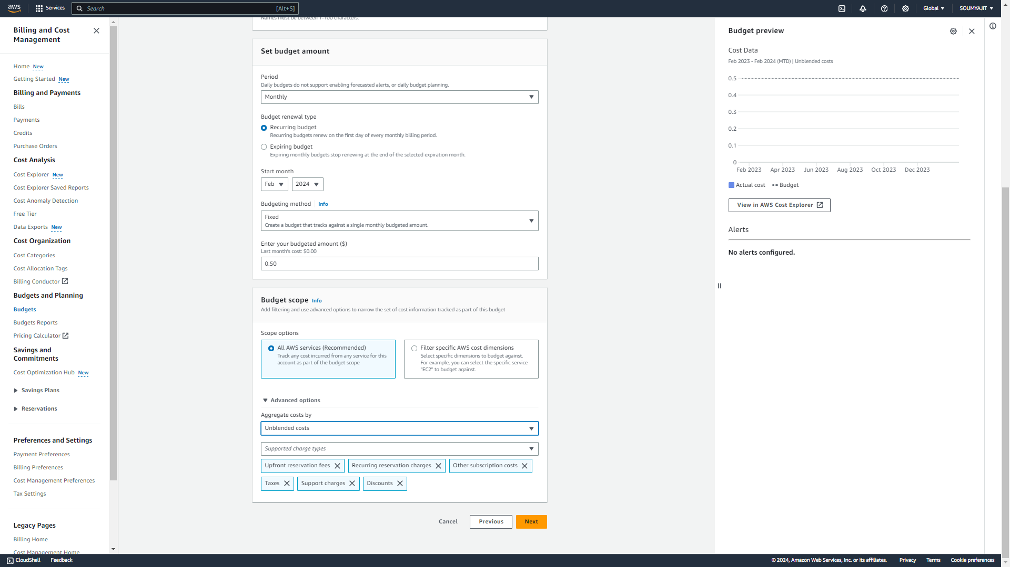

1. Configure alerts->click on ‘Add an alert threshold’ and click ‘Next’.

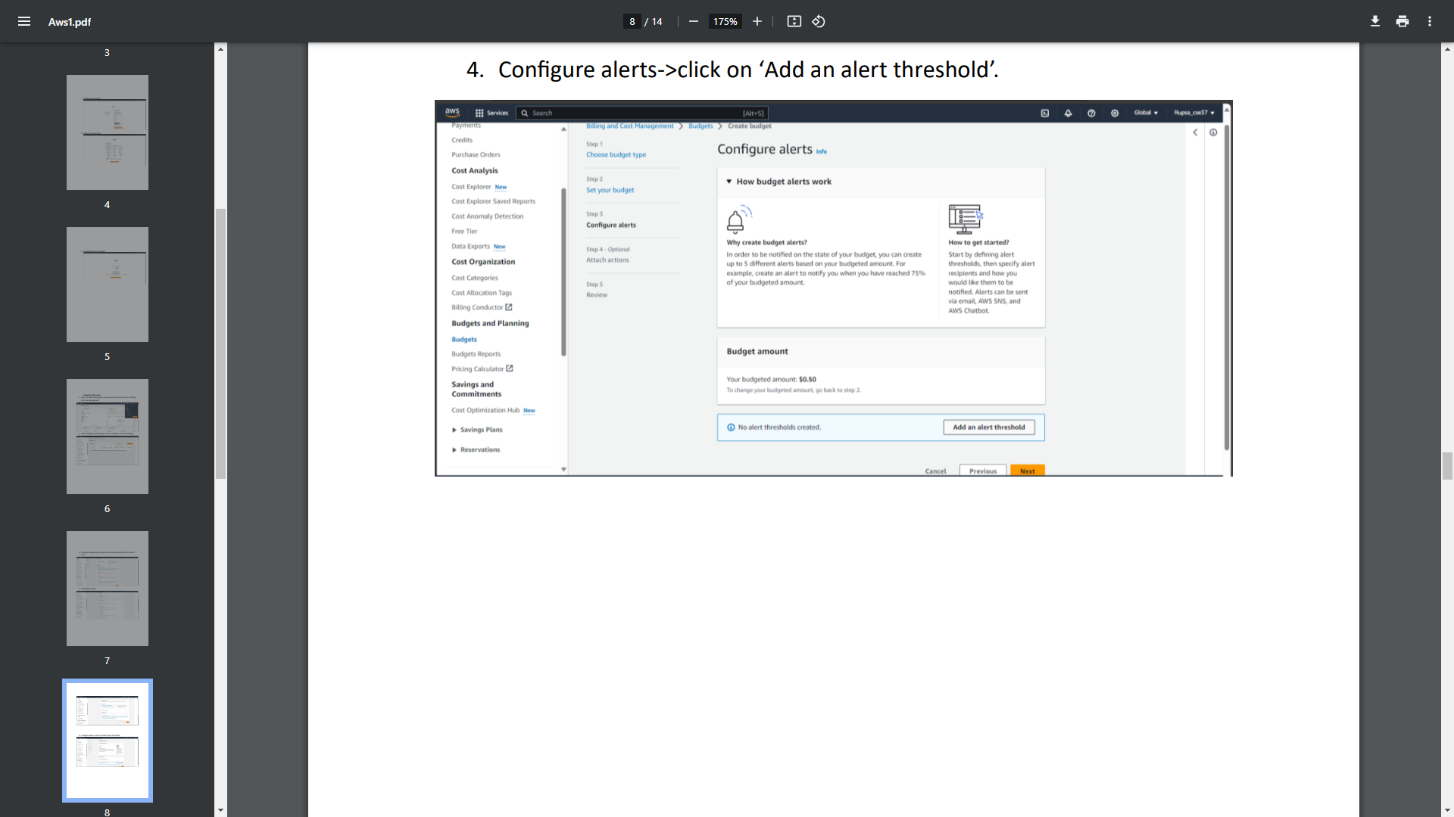

1. Set alert threshold value. If we want to create more than one alert threshold then click on ‘Add an alert threshold’ otherwise click on ‘Next’.

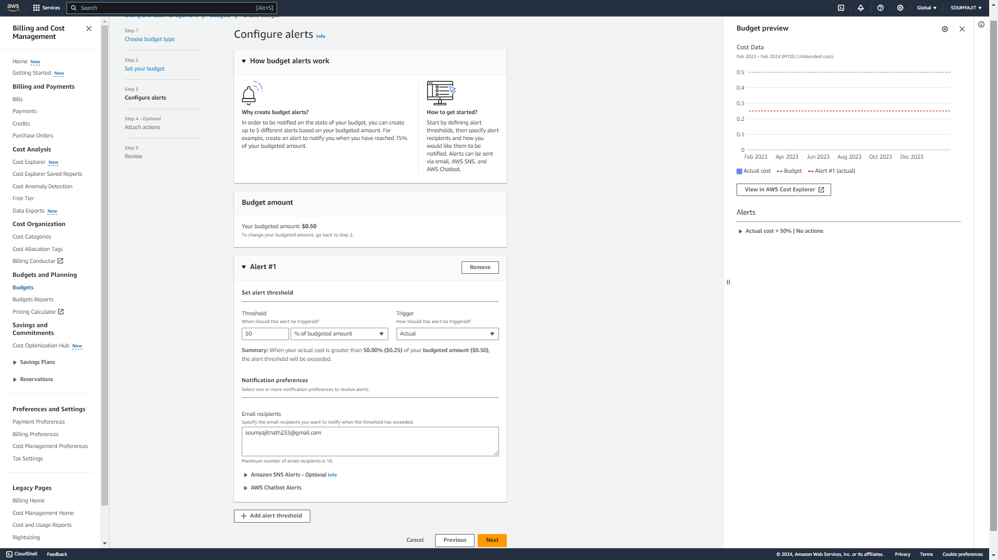

1. Again click ‘Next’.

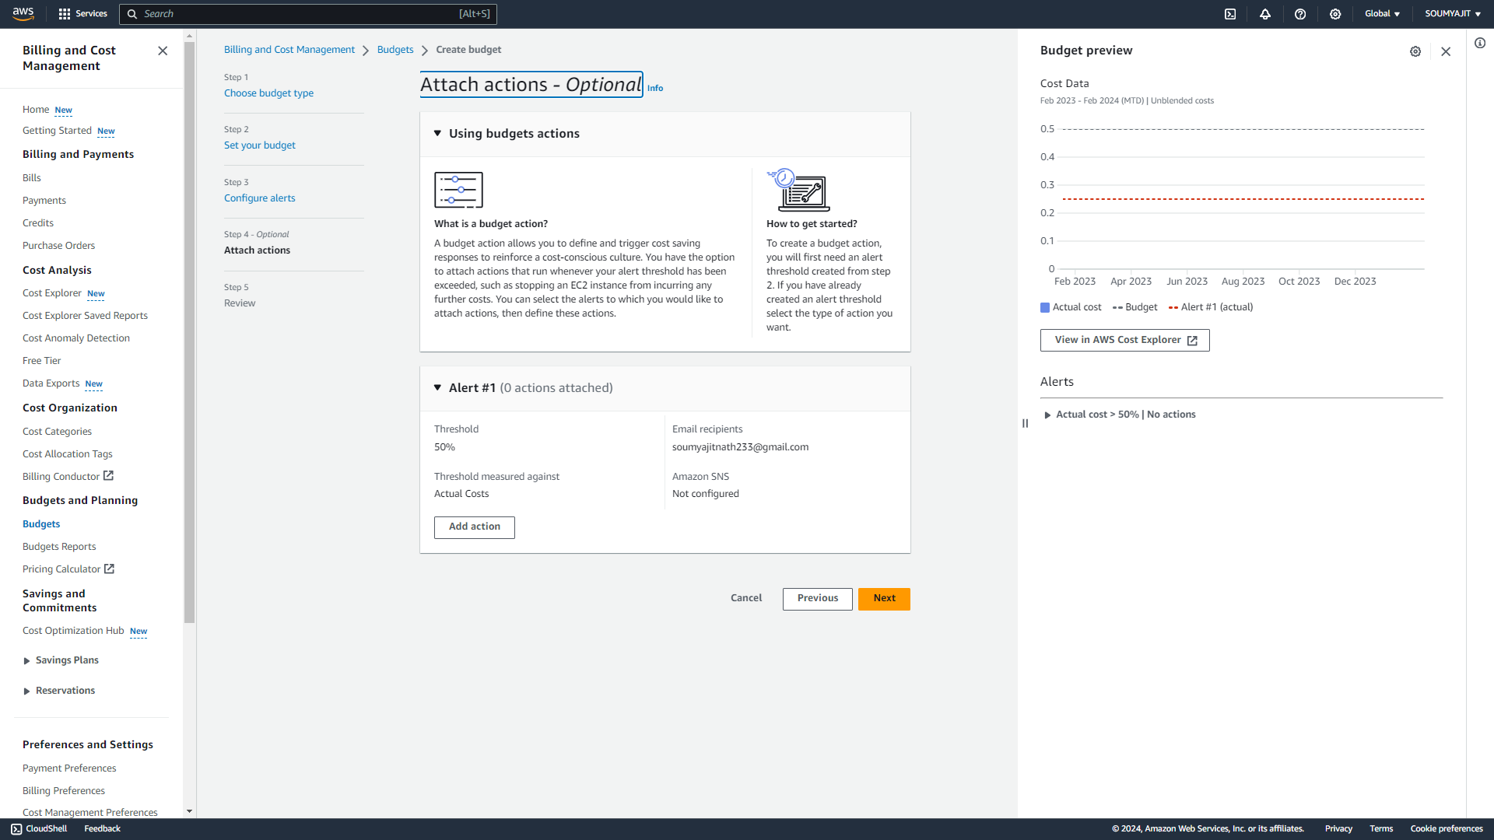

1. Review the budget and then click on ‘Create budget’.

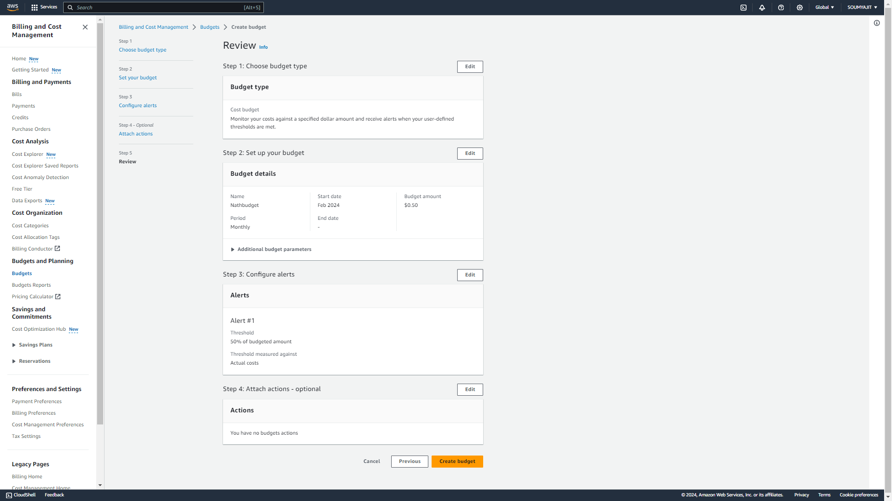

1. Nathbudget created successfully.

